科学数据银行（Science Data Bank）获得国际认证和推荐证明

1. ScienceDB国际平台注册情况（共4家）
2. FAIRsharing

https://doi.org/10.25504/FAIRsharing.Tb0BKn

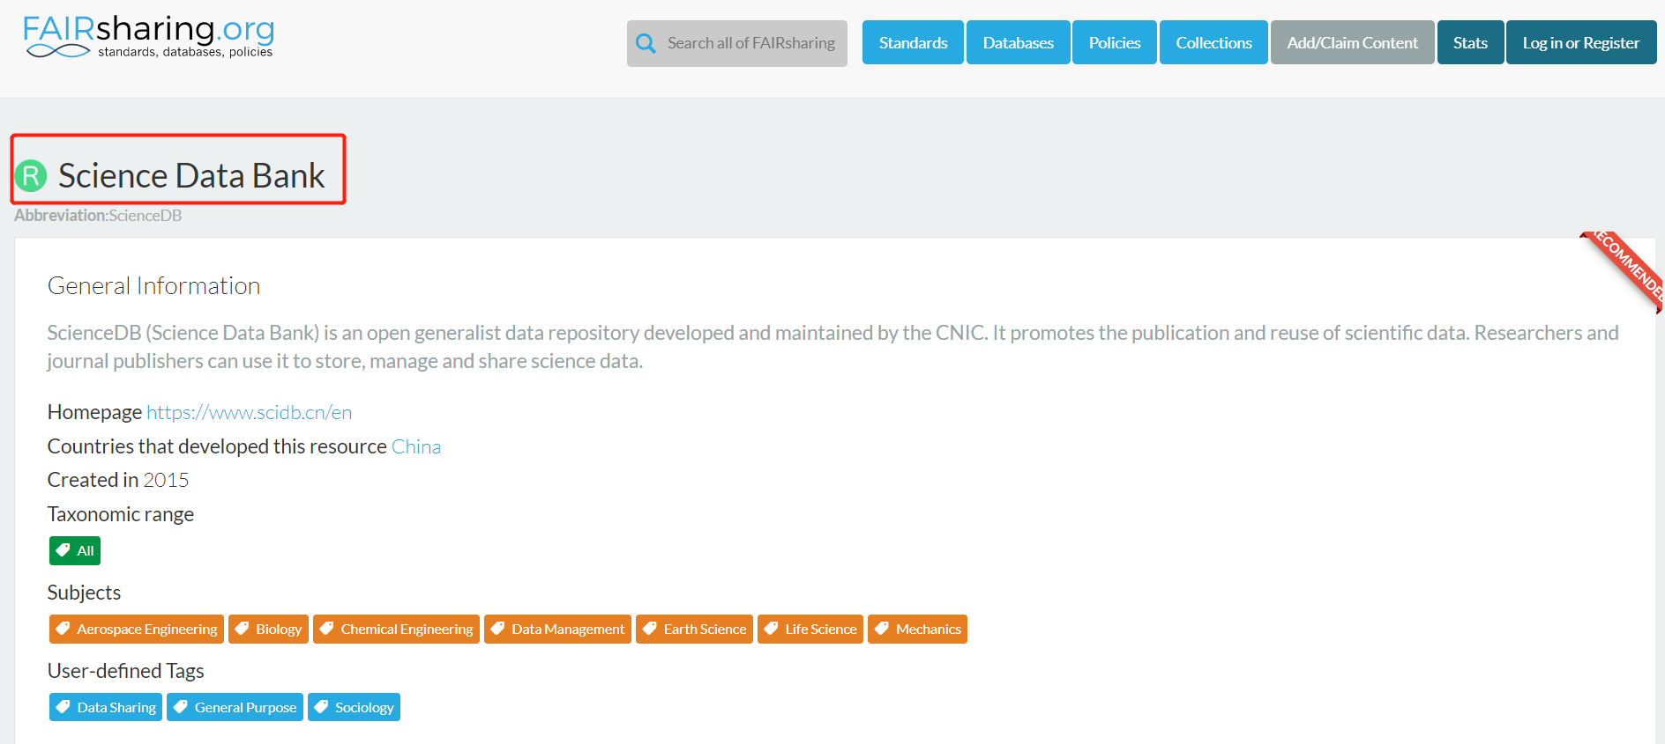

1. re3data

https://doi.org/10.17616/R31NJMNT

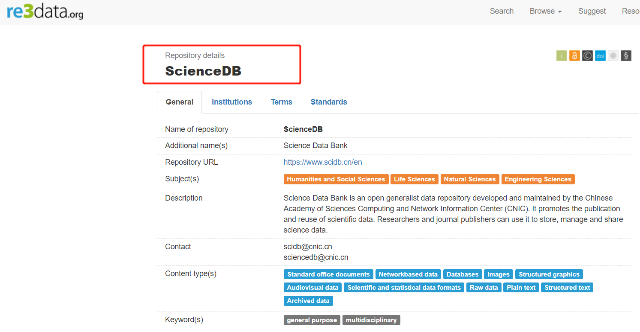

1. Open DOAR

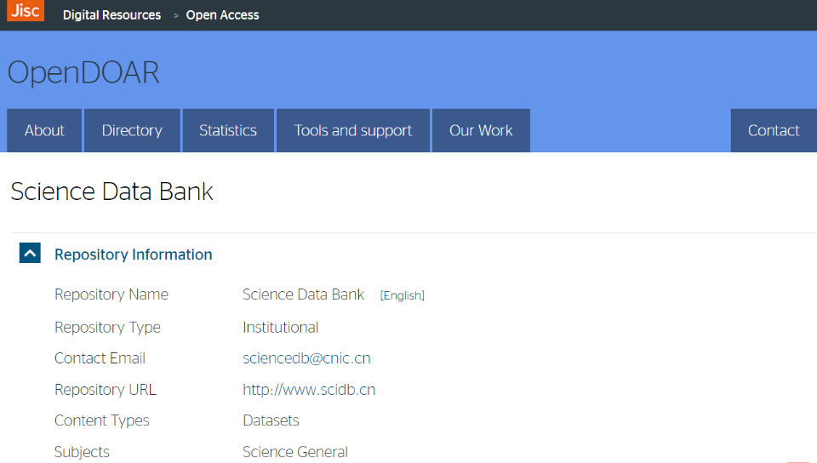https://v2.sherpa.ac.uk/id/repository/9768

1. ROAR

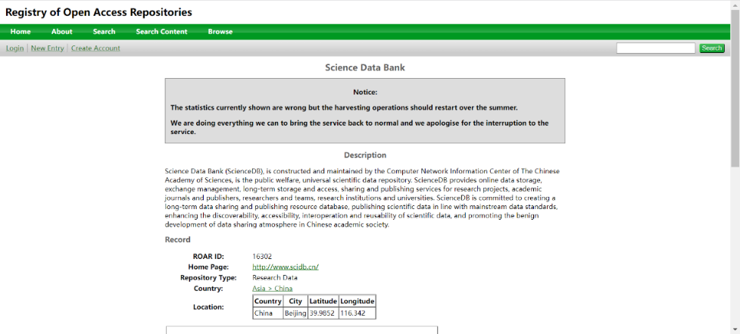<http://roar.eprints.org/16302/>

1. ScienceDB被国际主流期刊、出版社推荐情况（共9家）
2. Springer Nature

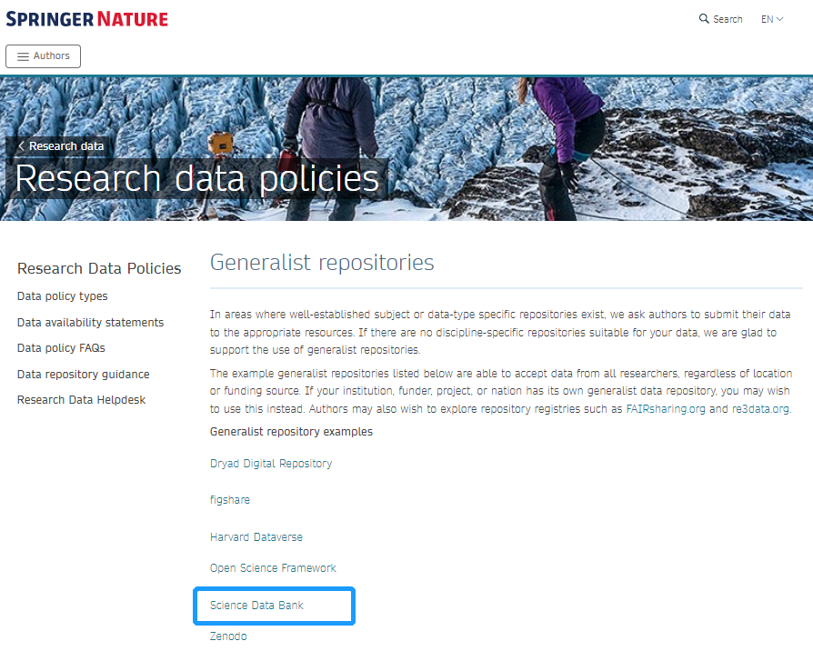www.springernature.com/gp/authors/research-data-policy/repositories-general/12327166

1. Cell Press

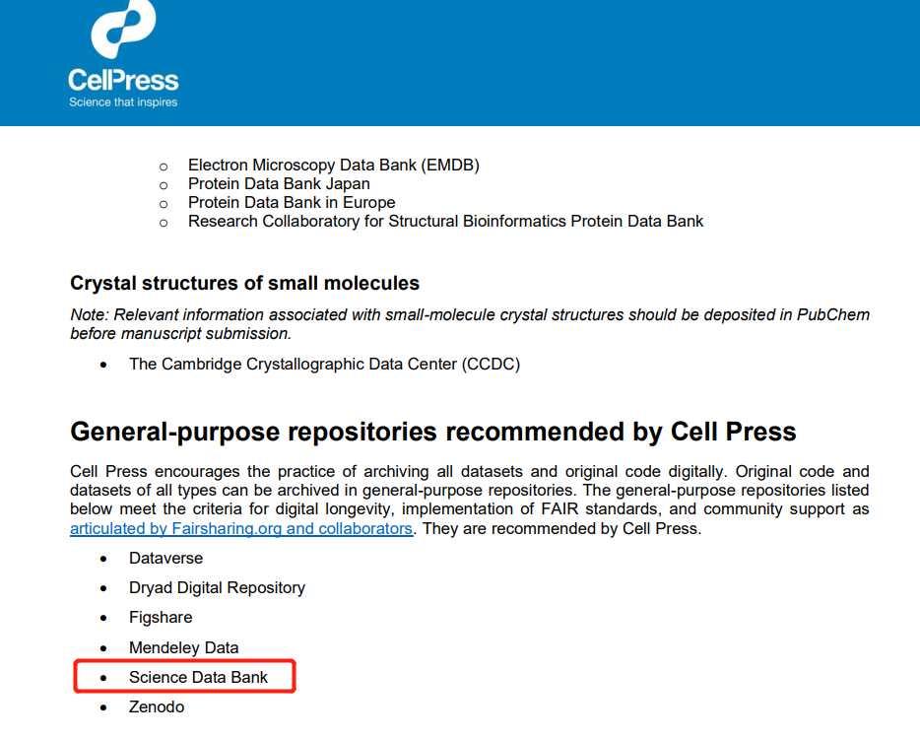https://marlin-prod.literatumonline.com/pb-assets/journals/research/cellpress/data/RecommendRepositories.pdf

1. AGU

https://data.agu.org/resources/useful-domain-repositories

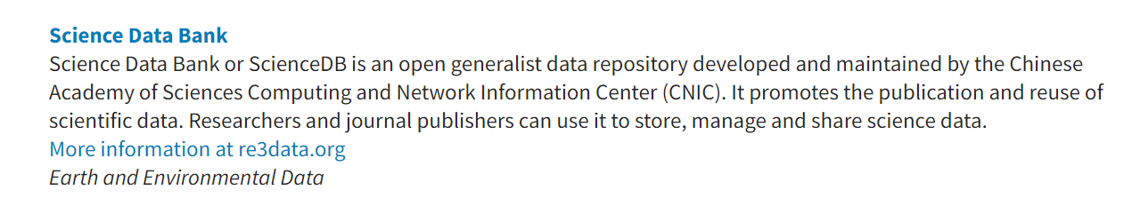

1. Elife

https://beta.fairsharing.org/FAIRsharing.F0QmCP

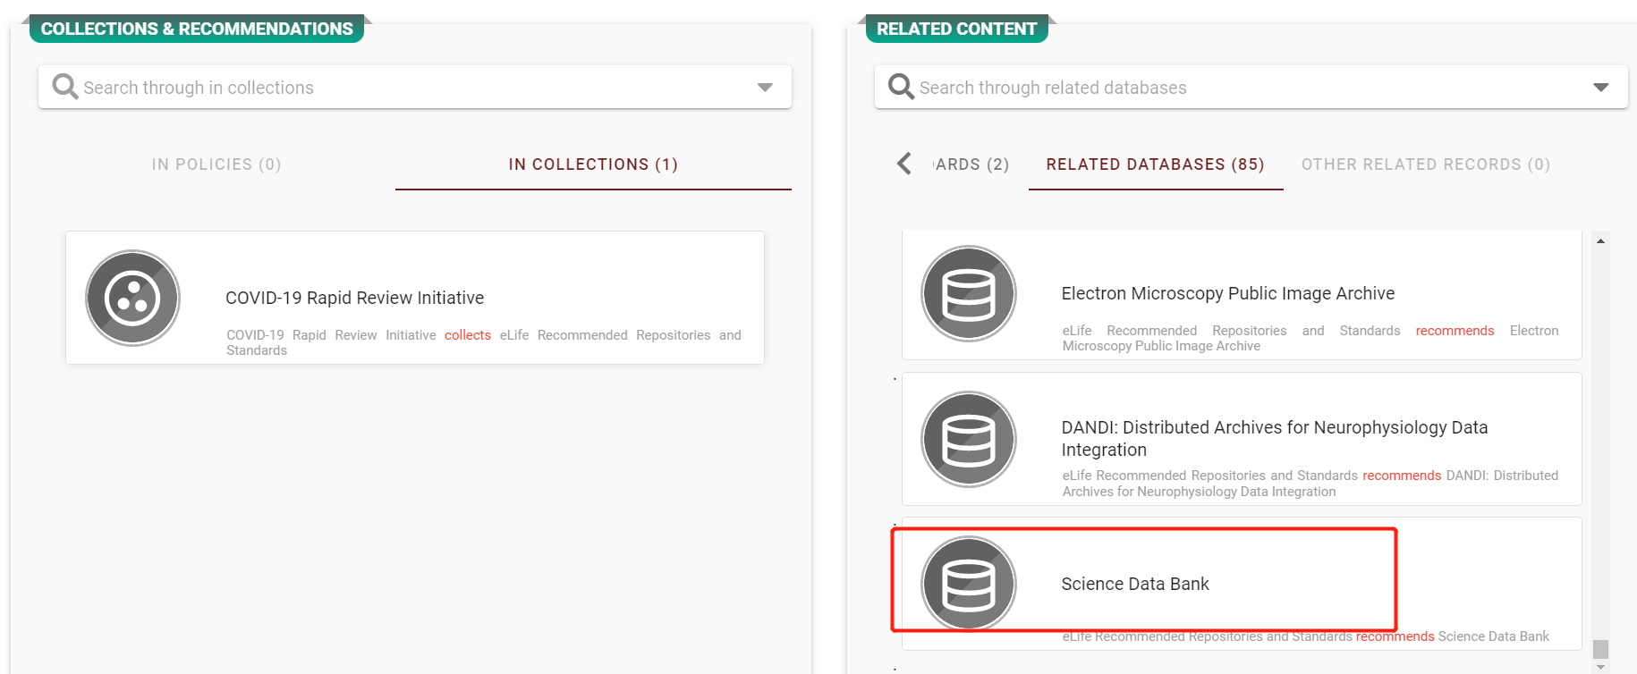

1. Taylor & Francis

https://authorservices.taylorandfrancis.com/data-sharing/share-your-data/repositories/

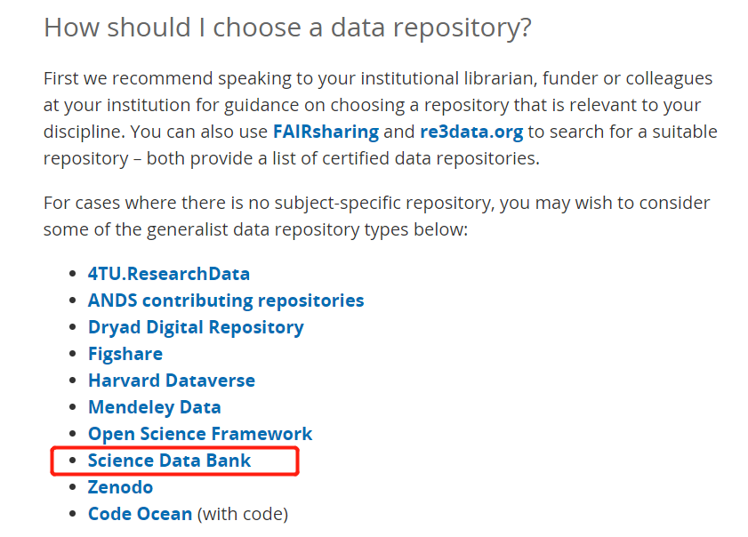

1. Elsevier

https://fairsharing.org/bsg-p000100/

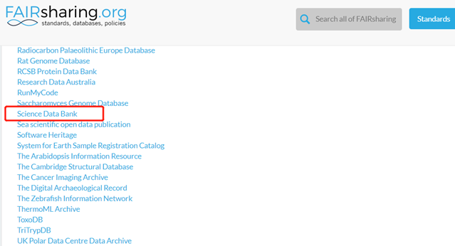

1. 科学出版社

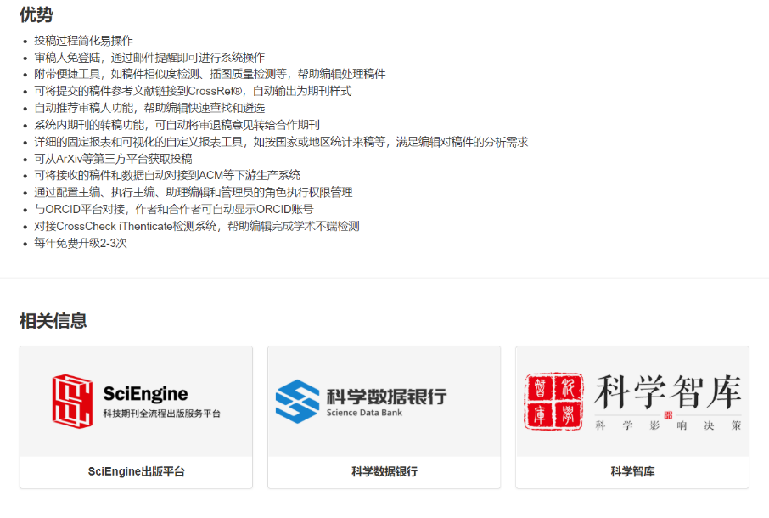https://www.scicloudcenter.com/Portal/main/home

1. Wiley（间接推荐）

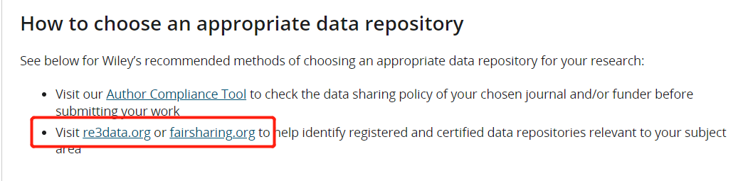https://authorservices.wiley.com/author-resources/Journal-Authors/open-access/data-sharing-citation/data-sharing-policy.html

1. Sage（间接推荐）

https://uk.sagepub.com/en-gb/asi/research-data-sharing-faqs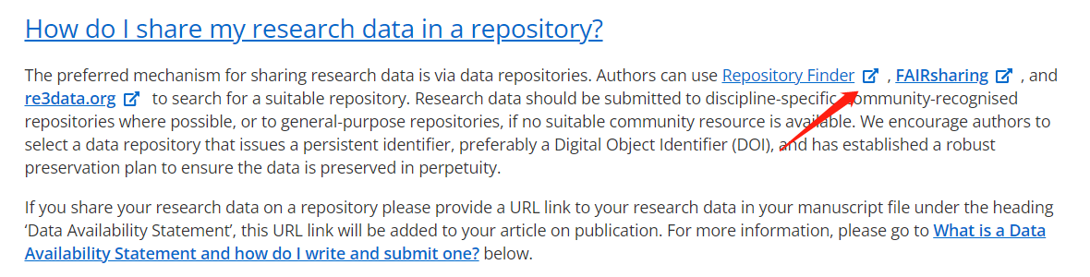

1. RSC

https://www.rsc.org/journals-books-databases/author-and-reviewer-hub/authors-information/prepare-and-format/data-sharing/#generalrepositories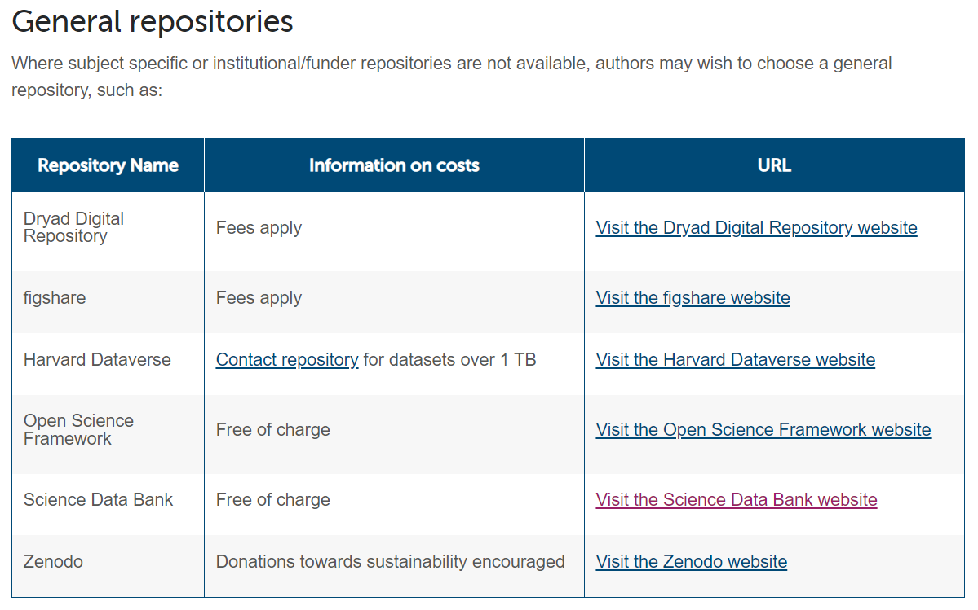

1. ACS

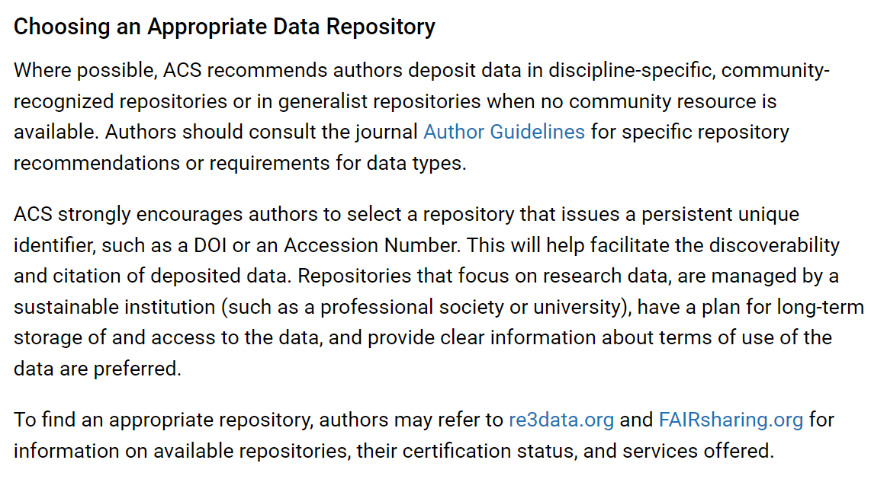<https://publish.acs.org/publish/data_policy>

1. Hindawi Publishing Corporation

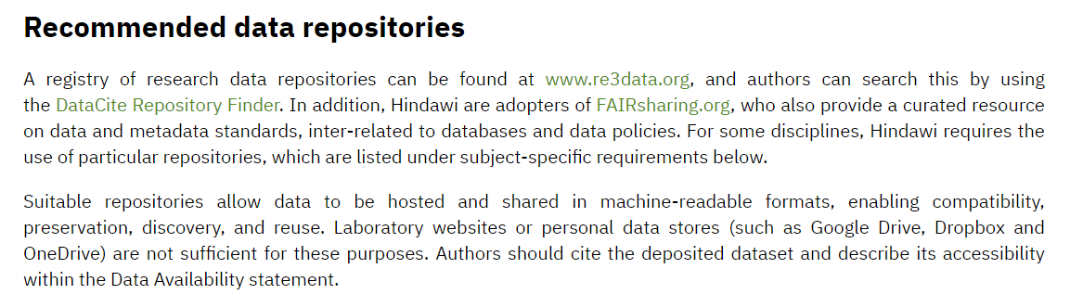<https://www.hindawi.com/publish-research/authors/research-data/#how-to-share-your-data>

1. Cambridge University Press

https://www.data.cam.ac.uk/repository

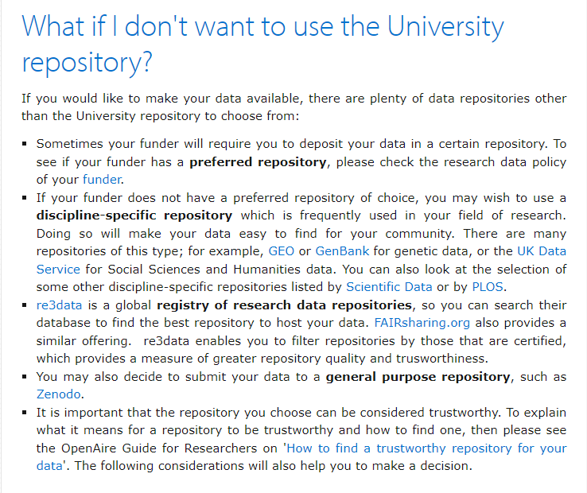

1. Emerald

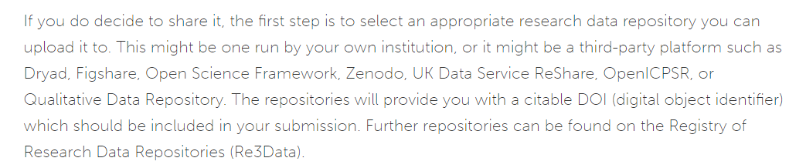<https://www.emeraldgrouppublishing.com/publish-with-us/author-policies/our-open-research-policies#open-data>

1. American Psychological Association (APA)

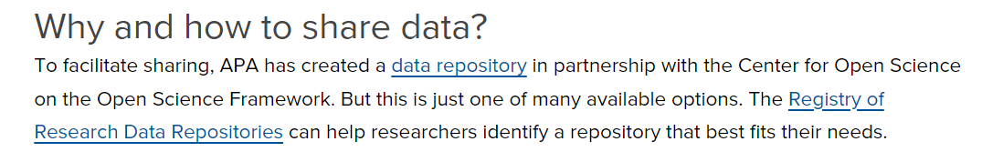<https://www.apa.org/pubs/journals/resources/data-sharing>

三、 ScienceDB被数据索引平台收录情况（共4家）

1. Data Citation Index – Web of Science

https://clarivate.com/webofsciencegroup/master-data-repository-list/

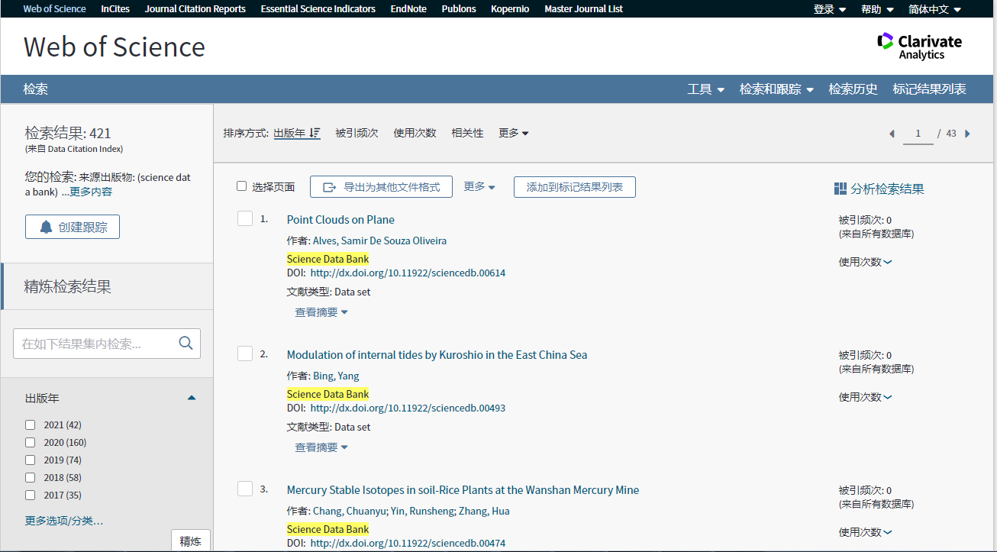

1. Mendeley Data

https://data.mendeley.com/research-data/?search=ScienceDB

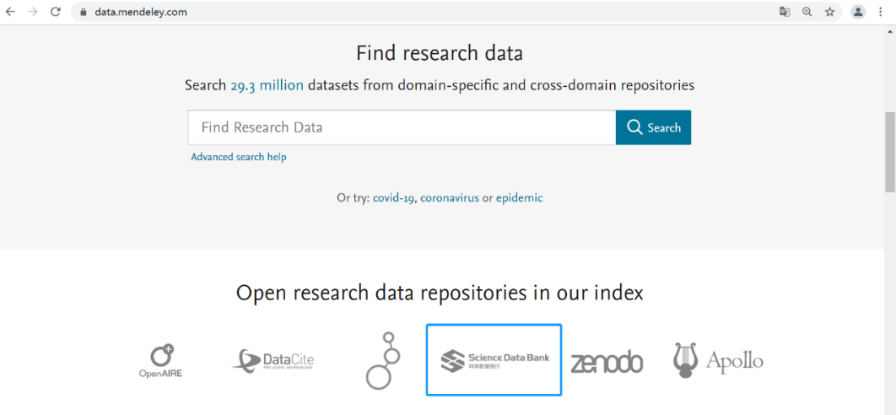

1. Google Dataset Search

https://datasetsearch.research.google.com/search?query=sciencedb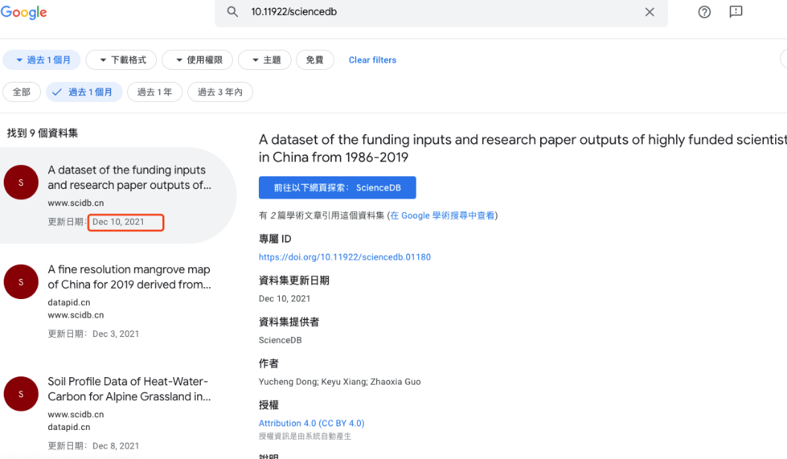

1. BASE

https://www.base-search.net/Search/Results?q=coll:ftsciendatabank K

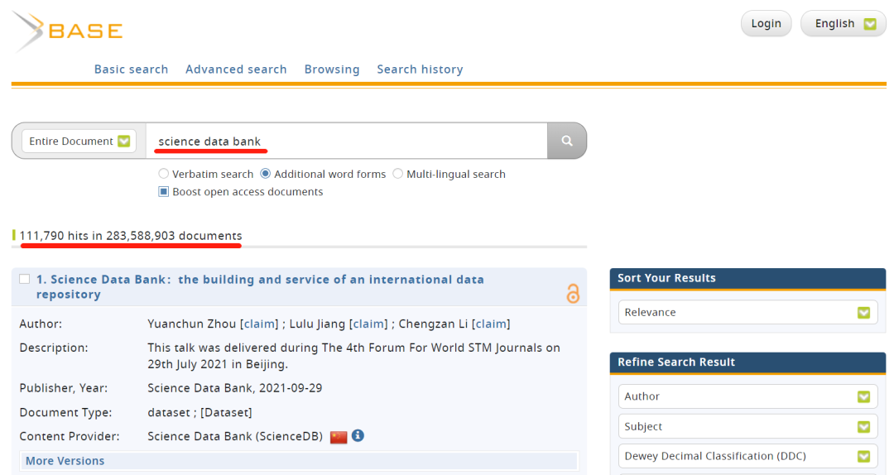

1. DataCite

https://search.datacite.org/works?query=Science+Data+Bank

1. Dimensions

https://app.dimensions.ai/discover/data_set?search_mode=content&or_facet_year=2022&or_facet_repository=cnic.sciencedb

1. OpenAIRE

https://explore.openaire.eu/search/content-providers?f0=q&fv0=science%2520data%2520bank